# Experiment-9

**Aim:** implementation of basic network command and Network configuration commands.

**Apparatus (Software):** Command Prompt And Packet Tracer.

**Procedure:** To do this EXPERIMENT- follows these steps:

In this EXPERIMENT- students have to understand basic networking commands e.g ping, tracert etc.

All commands related to Network configuration which includes how to switch to privilege mode and normal mode and how to configure router interface and how to save this configuration to flash memory or permanent memory.

This commands includes

* Configuring the Router commands
* General Commands to configure network
* Privileged Mode commands of a router
* Router Processes & Statistics
* IP Commands
* Other IP Commands e.g. show ip route etc.

**1.ping:** ping(8) sends an ICMP ECHO_REQUEST packet to the specified host. If the host responds, you get an ICMP packet back. Sound strange? Well, you can “ping” an IP address to see if a machine is alive. If there is no response, you know something is wrong.

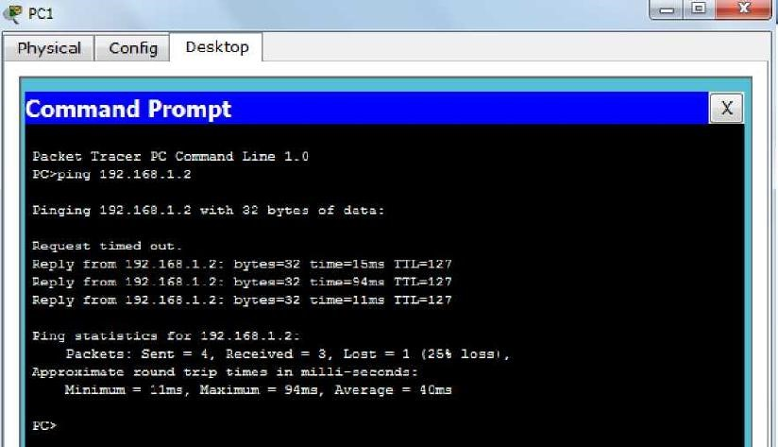

**2.Traceroute:**

Tracert is a command which can show you the path a packet of information takes from your computer to one you specify. It will list all the routers it passes through until it reaches its destination, or fails to and is discarded. In addition to this, it will tell you how long each 'hop' from router to router takes.

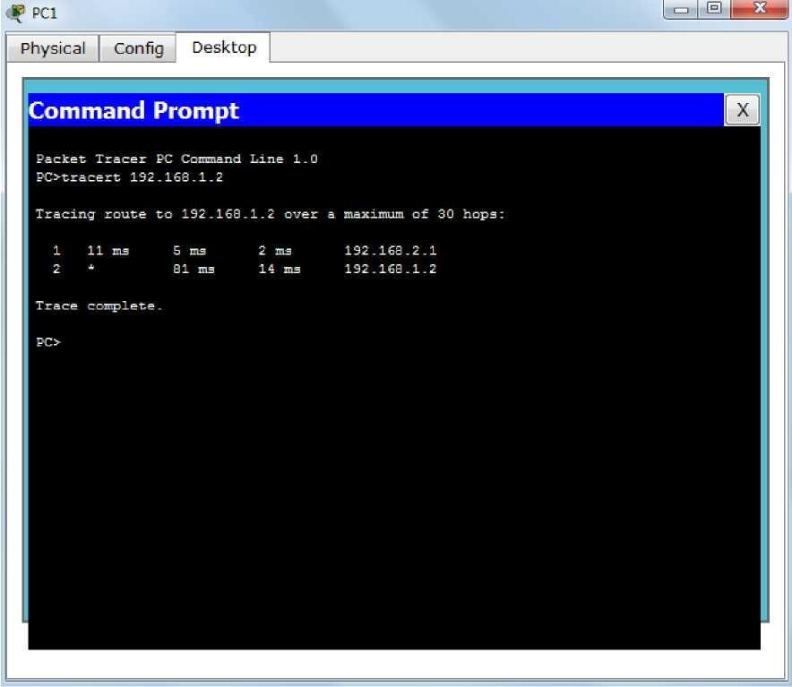

**3.nslookup:**

Displays information from Domain Name System (DNS) name servers.

NOTE If you write the command as above it shows as default your pc's server name firstly.

C:\Users\Thyagarajan>nslookup

Default Server: dns.google

Address: 2001:4860:4860::8888

> nslookup www.svcetedu.org

Server: svcetedu.org

Address: 43.225.55.220

Aliases: www.svcetedu.org

*** www.svcetedu.org can't find nslookup: Query refused

> nslookup www.gmail.com

Server: googlemail.l.google.com

Addresses: 2404:6800:4002:80d::2005

172.217.167.197

Aliases: www.gmail.com

mail.google.com

DNS request timed out.

timeout was 2 seconds.

DNS request timed out.

timeout was 2 seconds.

*** Request to www.gmail.com timed-out

**4.pathping:**

A better version of tracert that gives you statics about packet lost and latency.

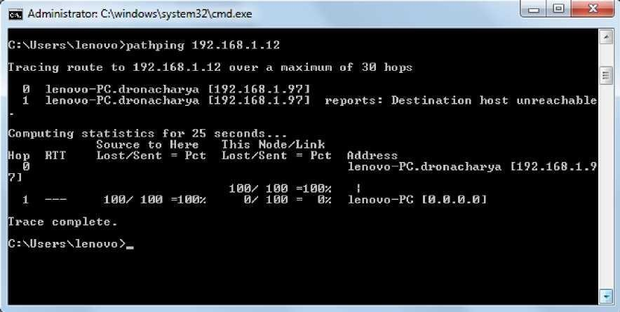

**EXPERIMENT-10**

Ex. No. 10. Configure Host IP, Subnet Mask and Default Gateway in a System in LAN (TCP/IP Configuration).

Aim:

To Configure IP Address in a system in LAN (TCP/IP Configuration) and Configure DNS to establish

interconnection between systems

Principle: Following is required to be study under this practical.

• Classification of IP address

Class A 1.0.0.1 to 126.255.255.254 Supports 16 million hosts on each of 127 networks.

Class B 128.1.0.1 to 191.255.255.254 Supports 65,000 hosts on each of 16,000 networks.

Class C 192.0.1.1 to 223.255.254.254 Supports 254 hosts on each of 2 million networks.

Class D 224.0.0.0 to 239.255.255.255 Reserved for multicast groups.

Class E 240.0.0.0 to 254.255.255.254 Reserved.

• Sub netting

* Subnet ting is dividing the network into two or more networks is called subnet ting.

**Procedure:**

(a) Steps to configure IP address, Subnet mask and Default Gateway:

1. Click on the Start button and select Control Panel then Network and Internet Connections.

2. Click Network and Internet Connections.

3. Right click on the Local Area Connection icon and select Properties.

4. Select Internet Protocol (TCP/IP).

5. Click on the Properties button.

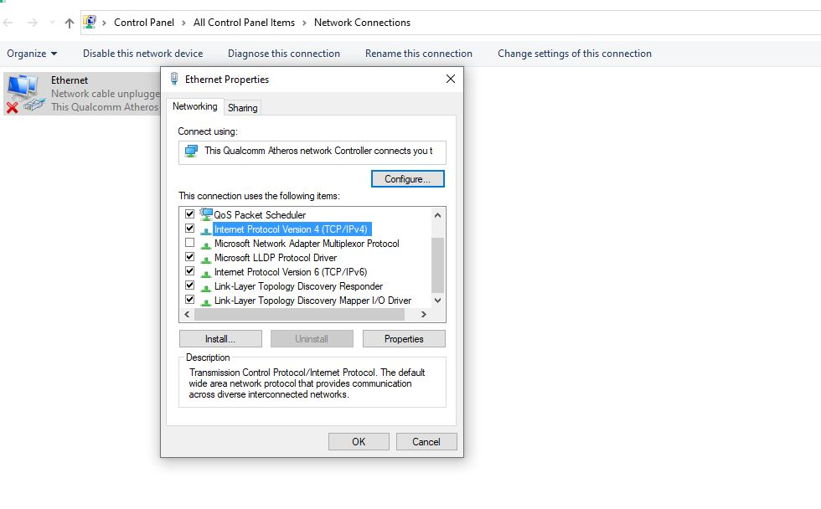

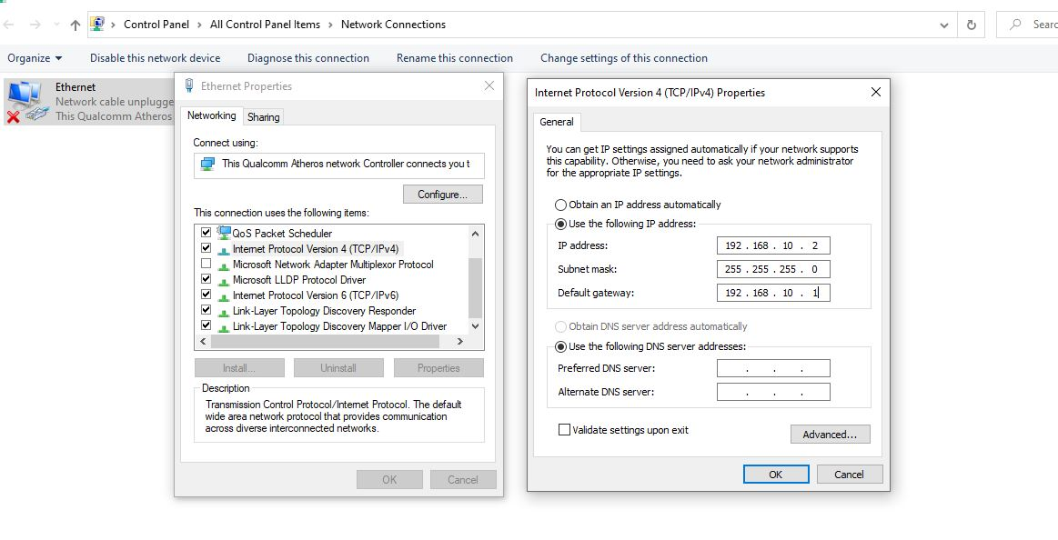

6. Uncheck that Obtain an IP address automatically and Obtain DNS server address automatically and put

IP, Subnet mask & Default Gateways.

7. Click on the Advanced button and select the DNS tab in the Advanced TCP/IP Settings window.

8. Ensure that Register this connection's addresses in DNS is not selected.

9. Click OK, OK, then Close to close all boxes.

Result :

Configuration of IP Address in a system in LAN (TCP/IP Configuration) and Configuration to establish

interconnection between systems have been done successfully